OCR GCE A
COMPUTER SCIENCE PROJECT
H446-03

Name : <Abdur Rahman Mohammed>
Candidate Number : <INSERT CANDIDATE NUMBER>
<Institution Name> : <48219>
Title of Project : <Sun Samurai>

H446-03 – Project CONTENTS

Table of Contents
Table of Contents 2
A. Analysis 4
Problem overview 4
stakeholders 4
how will the problem be solved using computational methods 5
Thinking abstractly 5
thinking ahead 6
Thinking Procedurally 6
Research 9
Interview with Alex walsh so i can meet the minimum requirements 9
A review of the interview 10
Research into Super mario bros 11
Title screen 12
Gameplay 13
time/Scoring/lives system 14
Enemies 15
Death 15
Collectables 16
Finish line/ checkpoint 16
How do the different features effect the game play of SUper Mario 17
The features which will be used for my game 18
Interview script 18
Summary of the interview 20
Hardware and software requiremtns 22
Hardware requirements & recommended 22
Software requirements 23
Features of the solution 24
B. design 27
Usability features 32
Classes 38
Algorithms 40
KEY VARIABLES AND DATA STRUCTURE 48
Main menu class 48
Levels class 49
Main player class 50
enemy class 53
collectables class 55
global variables and methods 56
Test data 58
Developing the coded solution (“The development story”) 59
D. Evaluation 59
Project Appendixes 60

A. Analysis

Problem overview
For my project I am intending on creating a game which is similar to the Mario game made by Nintendo. This is a retro platformer game where you are to fight enemies and complete each level by reaching the end. There are also collectables which give you power ups and regain your health. Every time you kill an enemy your score increases on your score board. Once you have reached the end of the game or you kill a certain number of enemies you are automatically sent to the next level.

For this game to work, it will require a main menu system for navigation, then it will need a level system so that the player can progress in the game, it will need enemies that are able to deal damage and take damage. This game will need a health bar system for the player so then we can give them a game over screen.

stakeholders
The game is designed for anyone as it has simple game mechanics and graphics, so it is easy to understand what the stakeholder needs to do to solve the problem. This is a retro game based off Mario, so it is a fictious game so there are no real-life elements and dialogue of the characters. Therefore, the age limit to who will be able to play the game will be reduced. These features of my game will target the audience of the age 6+ as there will be death in the game but it will not be as horrifying it will just be a simple fall and then the everything restarts, it will excite the player because of the flashing animations that will be used. This game differs to how most people play games such as phones, tablets and consoles because it requires simple clicks on the mouse and 2 essential keys which make the player move.
My target audience is people around my age who enjoy platformer-style games and are interested in anime. I took this into consideration when choosing my first game tester. I opted for a fellow student who matched my criteria perfectly, therefore making him the perfect tester for my game.
I have epitomized Alex Walsh to be my games first user for the target audience. They are in my school who are interested in anime and gaming,

how will the problem be solved using computational methods
The problem can be solved by the computational method as my program is most compatible with laptop and desktop computers, so this makes more compatible to solve complex problems such as decompositions as I am implementing object orientated programming into the project. My program structure is set out straight forward as I have used many functions for each sprite and background and the movements. I have used abstraction to reduce complexity and increase efficiency with my code. My code is set a simple structure because you can hide the functions and procedures by collapsing them.

Thinking abstractly
I found out what I needed to add into my program and what I needed to remove to make my game simpler since this is what abstraction means so I can apply thinking abstractly whilst I am making my game.
I am trying to abstract sun samurai:
- Since it is a platform game it needs to be 2d so anything 3d needs to be removed
- To add functions to the background, so it does not get in the way of my character
- I need to add a storyline, so it makes It easier for the user to understand how actually play the game
- To remove sounds which have no meaning to it so it does not confuse the player
- To add a level map to indicate which level the player needs to be on to moving forward

thinking ahead
The benefit of thinking ahead is extremely vital whilst making large projects as it helps you plan, and it will save time and effort making your project. The way I would think ahead in my project would be:
- I plan to use VS code as it is widely used by many programmers, and it gives me a wide range of support
- The module which I will be using is Pygame as it is universally adaptable, and the graphics will fit the retro theme
- In my game I will add 1 main character 6 boss fights and 10 levels
- Too make my sprite importation easier I will cut my sprites animation and load them into my project file so It will be much more efficient as it will save my time by making it later
- Firstly, the main menu will be added after that the 10 levels and diving into the gameplay I will add a health by and a score system

Thinking Procedurally
Thinking procedurally will be highly beneficial as working simultaneously will be possible for example I will have a scrolling background, and this background moves when my character moves. It is somewhat like thinking ahead as it makes it more efficient and less time consuming.
This is a structure of the problem being divided

Sun Samurai

Interior of the game
Score Board
controls
Player

points
Main menu
Keyboard buttons
One player game

Level Display
Mouse buttons
Game over

I have divided the problem into 4 main parts, thinking procedurally will be beneficial because I will be able to become more efficient as I will do more things simultaneously.
Player:
This will tell the user that there will be only one player, and their goal is to cut down any enemies coming towards them. This will give them experience which will go down to the level and the player will have to avoid getting hit by the enemy other wise their health bar will get affected
Control:
This is a very vital part of the problem so then it will allow the user to interact with the game. The keyboard buttons will allow the user to control the player by moving them and accessing their special features the mouse buttons are there for the extra attributes of the player. For example, to be able to move the player you will need to use the A and D keys.
Interior of the game:
The interior of the game will create the in-depth structure of game. Firstly, the user will be able to see the main menu where there will be two buttons on the screen labelled start and exit. Once the player clicks start, they will be able to go to the levels where there are 5 levels, the player will start at level 1 as it will give them an introduction and experience of the game. The player will have 3 lives, and each life depends on their health bar if their health bar reaches 0 it will go on their second life then if their health bar goes 0 again, they will have one life left if that life goes on 0 then they will have to restart and the sign to show that is they will see a game over screen.
Level ups:
The player will be able to collect experience points which will be used to increase their levels. When their level bar fills up then they will be able to be have access to more skills there will be a total of 10 levels.

Research

Interview with Alex walsh so i can meet the minimum requirements

what makes a good game
What game does it replicate:
Yes it does have demon slayer elements through its character and it does replicate Mario as it is a platformer game
Does the background music affect your gameplay:
Background music does not affect the gameplay but it creates an ambient environment
Do you think I should add more playable characters and add different weapons:
No because it will be easier to use just one player and one weapon
Do you want a score board:
Yes so It will tell me how good I am at the game
Should I add a difficulty level to make the game more competitive:
Yes because it will make the game more enjoyable
Do you think I should add a setting menu.
Yes because it will make it easier for the player to adjust to their preferences
What are your thoughts on platform games
I enjoy playing platform games because its simple

Are more boss fights wanted
Do you think having more boss fights will make the game more interesting and enjoyable?
Yes because it gives the player an incentive to play the game
Would you want each boss to be harder to fight?
Yes because it wont be boring.

A review of the interview
This interview gave me a clear sight of how I am going to plan my game and it I know what the stakeholder wants to make the game intriguing. Me and the client thought that the sounds and animations were vital for the game play so then it will differentiate my game with Mario as it will be unique
We have agreed on background music, sound effects and flashy animations. The Stakeholder would want to the game to be simple so we will use pixel sprites. Although we want the game to be simple, we want add elements of realistic features such as adding gravity when the player jumps.
For the game interiors we have concluded that we will use a level system so this gives the player more of an enjoyable experience as there will be

Research into Super mario bros
Super Mario bros is a platformer game where the users move the player forwards to complete the game whilst they are moving forwards they are faced with obstacles and challenges once they have reached the end they are having to jump or go through a flag which marks their checkpoint and saves their current status and progress in the game. The player gets special items which allow them to upgrade and have powers; to kill the enemies, they can jump on them, or they could avoid and ignore them.
The game has levels and different worlds as they progress to the next levels, they get closer towards the final boss, each level will become more intense, and it will have different backgrounds to engage the player even more. This is

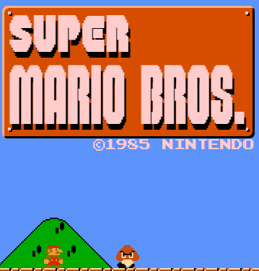
Title screen

When the game starts the player is presented with the title super Mario Bros

Gameplay
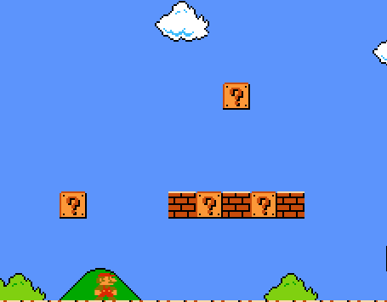
So there is a screen scroll so it continuous until it goes to the flag
Mario has to run through these blocks and he meets the enemies

time/Scoring/lives system
Score: represents how many enemies you killed it gives you 100 points per kill
Coins: this is a counter for how many coins you collect
World: this tells you which world you are in and the level
Time: the game times you in seconds and it shows how long you took to complete the level
Lives: This tells you how many lives you have and you usually start with 10

Enemies
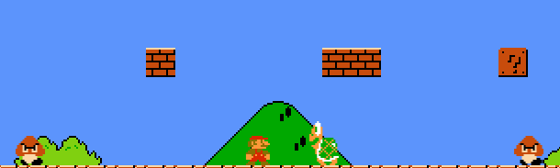
Mario has to try to avoid these enemies otherwise he will lose a life and restart at his last checkpoint. He could avoid them by jumping over but he could also jump on them.

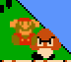
Death

This is the animation that occurs when Mario touches the enemy causing him to fall down the map and he restarts

Collectables
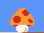

This is a lucky block which usually gives you coins but sometimes
It also gives you special mushrooms which help you grow taller
Or to give you more health

Finish line/ checkpoint
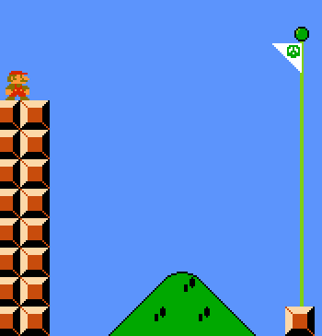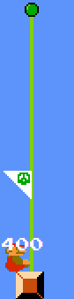
When Mario comes close to the finish he is face with a flag which he needs to jump on in order to mark his completion of that level. And in game context it shows that this area is now his territory

How do the different features effect the game play of SUper Mario
Menu:
- This is important because it allows the user to interact with the game as it allows the user to switch their world save their progress, choose which player they want to be.
Failure in the game:
- The way a player achieves failure is when they lose all their lives and at that point, they will be notified with a sound which indicates they have failed.
How are sounds used in the game:
- They are used for animations such as jumping, attacking, getting collectable items. When a player dies or when a enemy dies. And there is also background music
How are animations used in the game:
- They are used to enhance the users experience because it tries to reflect real time since they run, their arms and legs are moving and when they die they fall down slowly.

The features which will be used for my game
Question layout:
Animations/Sounds:
- What sort of animations do you want for the skeletons
- What sort of animations do you want for the fire balls
- What sort of animations do you want for the poison flower
- What are the sounds you want for effects
Game interior:
- Would you like killing the enemies hard or easy
- How would you want to lose to the game
- How would you want to win to the game
- Do you think you will enjoy killing skeletons, fireballs, and poisons flowers
- Do you want a brief description of how to play the game
- What collectable items would you like
Level:
- How many map levels would you like
- Would you want to level up the player
- Would you want the enemies to give you experience points to level up
- How many experience points would you want each enemy to give you

Interview script

Animations/Sound
What sort of animations do you want for the skeletons
- I want them to have running animations
- I want them to have attacking animations
- I want them to have death animations
What sort of animations do you want for the fireball
- I want them to have running animations
- I want them to shoot fire balls
- I want them have death animations
What sort of animations do you want for the poison flower
- I want them to have running animations
- I want them have death animations
What are the sounds you want for effects
- I would like background music
- I would like a slashing noise for the sword
- I would like a noise to alert me if I die
- I would like a noise to alert me if I win

Game interior
Would you like killing the enemies to be easy or hard
- I would like it to be hard
How would you want to die
- If I touch the enemy I lose life points or if they shoot or touch me I die
How would you want win
- By completing the levels and killing the bosses
Do you think you will enjoy killing skeletons, fireballs, and poisons flowers
- Yes because I get very nostalgic about killing skeletons, fireballs, and poisons flowers
Do you want a brief description of how to play the game
- No because the looks simple enough play
What collectable items would you like
- I would like items which give superpowers or a special move and a health booste

Level
How many map levels would you like
- 5
Would you want to level up the player
- Yes so It will be fun to play
Would you want the enemies to give you experience points to level up
- Yes so it will give me an incentive to kill the enemy
How many experience points would you want each enemy to give you
- 100 points per kill

Summary of the interview

Animations/sounds
- I want animations for each character and non-playable character
- I would like background music
- Sound affects for killing
- Sound affects for winning
- Sound affects for being killed

Game interior
- I want the game to be hard
- I want to be killed by the enemy if I touch it or it shoots me
- I want to win by killing the enemy boss
- I want collectable items

Level
- I would like 5 levels
- I want to level up my player
- I want to get 100 points per kill
- I want a score board

Game controls
- To move the players left and right: A and D keys
- To make the player jump: S key
- To make the player punch: E key
- To make the player sword jab: left mouse button
- To make the player sword slash: right mouse button

Hardware and software requiremtns

Hardware requirements & recommended

Component | Minimum requirement | Recommended requirement
Processor  CPU | Dual-core, 2.0 GHz | Quad-core, 2.5 GHz or higher
Memory (RAM) | 2gb | 4GB or more
Graphics | Integrated (intel HD 4000 or newer | NVIDIA GTX 750
Storage | 500MB | 1GB
Display | 800x460 resolution | Full HD (1920x1080)
Audio | Standard | Standard
Input devices | Keyboard and mouse | Keyboard and mouse

Software requirements

Requirements | Explanation
Operating system | Windows 10 or later  macOS 10.15+  Linux(Ubuntu 20.04 or equivalent
Python version | Python 3.10 or later
Libraries | Pygame 2.0 which includes Mixer for sound effects
Game assets structure | Organized folders for sprites, Background images and audio files
Development tools | VS code or PyCharm for debugging

Features of the solution
Title screen | This will be displayed when the user runs the program, and it will indicate that they are loading into the game
Main menu | This is for usability so that it can help the user interact with the game by have the option to play now
Characters | The user will be given a character who has a sword and special powers. This is done so that it can match
Enemies will be given an increase in health | This is done so that it will become challenging to kill the enemy and, in the interview, they said they wanted the game to hard
The player will be given special power fruits | This will give the player some flashy animations and it will one shot 5 enemies per use
The heart item will give the player an extra 50 health points | This is because they can continue the level without being killed and this will reduce frustration
The sound effects will be used for any movement | So when the player moves his sword there will be a sound so for every type of movement except running and jumping there will be a sound effect.
The game over screen | This will indicate that the user has completed the game or that they must restart

No. | Requirements | Justification | Completed
1 | The player needs to move left right and should be able to jump | This is vital for gameplay as it will allow the user to get from place to place | ☒
2 | Includes a score system  So the player can track their progress | It gives the player feedback and encouragement | ☒
3 | Smooth animations for the player and enemy actions | It helps with better visualization so the player can have a better experience | ☒
4 | Adding a main menu for user interaction | This is vital so the player can navigate themselves into the game and if they don’t want to they can just press quit | ☒
5 | The player gains 10 points for every enemy they kill | This will give user score points which will be added to the score board | ☒
6 | When the player attacks the enemy they should disappear | This will act as indicator for the player so they will know that the enemy has been killed once they have been removed | ☒
7 | The player should have special moves | This increases the excitement of the game | ☒
Reference
Mario
Mario
Interview
Interview
Interview
mario
Interview

8 | The enemy should attack the player when they are in range | This is because then it will increase the intensity of the game because the player will have to dodge or attack the enemy to survive | ☒ | Interview
9 | Once the player has killed set number of enemy per level they move on to the next level | This is because it will allow the player to progress in the game whilst the intensity increases | ☒ | Mario
10 | The health bar should be affected when the enemy hits the player | This is important because it will indicate and alert the player to be careful and step away from the range | ☒ | Interview
11 | The health bar should increase when the player uses the potions to heal up | This will aid the player when trying to survive against the enemies | ☒ | Interview
12 | If the health bar reaches 0 then the player will see a game over screen | This will show that the player has died and the game is over so they will need to restart | ☒ | Interview

B. design

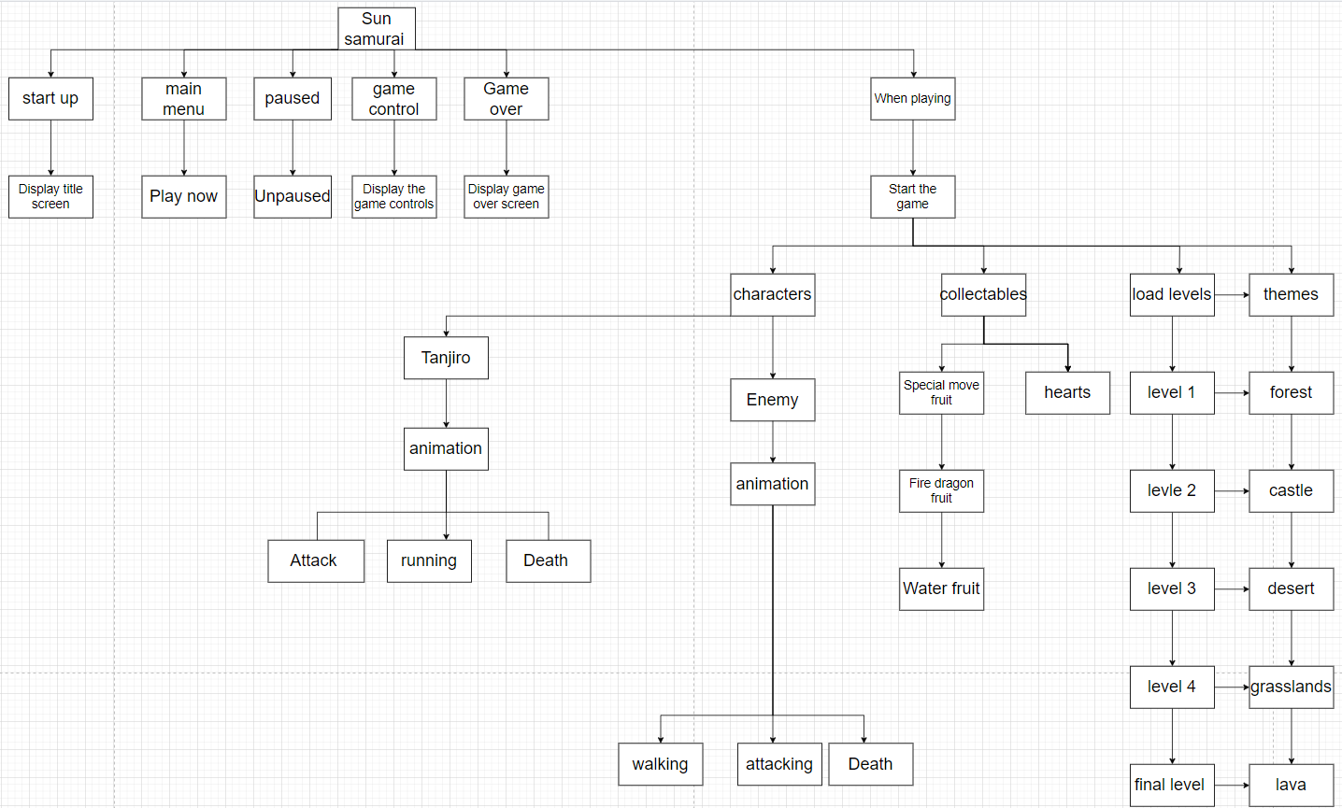

Structure diagram OF GAME states: Start up
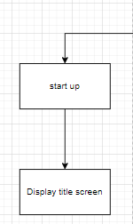
This game state helps me plan how my game will be presented, so when the game is run the player is presented with a title screen to indicate that the player is loading into the game.

Structure diagram OF GAME states: Main menu
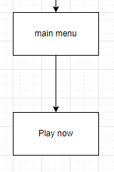
When the player is loaded into the game they are displayed with the main menu screen. In the main menu there will be one button called play now
Play now: this button is responsible for transporting the user from the main menu to the actual game

Structure diagram OF GAME states: Paused
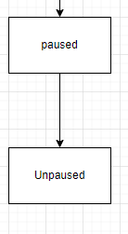
This game state is for usability so the player can interact with the game by pressing P to pause this temporarily freezes the game until the player presses the key P again

Structure diagram OF GAME states: game control
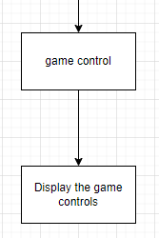
This is for displaying how to control the game

Structure diagram OF GAME states: game over
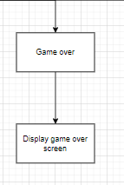
When the player either wins or loses the screen displays the image game over indicating that the player has either completed the game or needs to restart the game

Structure Diagram of game states: When playing

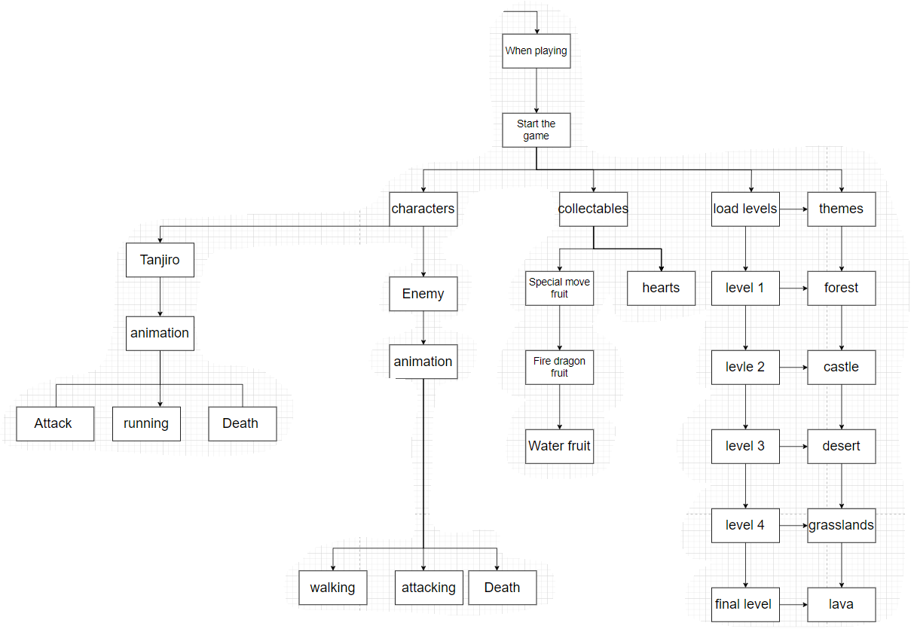

so when the player starts the game the characters, collectables, level maps are loaded into the game. First comes the level maps then once the player clicks on lets say level 1 they are teleported into the level 1 map where they start the game.
characters
They play as the character ‘tanjiro’ who has a jumping animation, movement animation, attack animation, and death animation.
then they enemies are loaded into the game they can walk, attack and die whilst they are alive

collectables
They spawn in at random, there are currently two collectable items which are the two potions (Red potion, blue potion) these potions give the player the ability to unlock special moves and gives full health to beat the level.
Load levels
This will display the level-maps in the game, there are currently 5 different levels and as you progress through each level the game will get harder.
level 1:
the theme of this level is a forest so the background will be a forest, it will be easy to kill enemies and COMPLETE LEVEL 1, the player will be obstructed by 10 enemies once they are killed the player can move on to level 2
level 2:
the theme of this level is a castle so the background will be a castle, it will get a little bit harder to kill enemies and to complete level 2, the player will be obstructed by 15 enemies. Once they are killed the player can move on to level 3
level 3:
the theme of this level is a desert so the background will be a desert, it will be harder to kill enemies and to complete level 4, the player will be obstructed by 20 enemies. Once they are killed the player can move on to level 4
level 4:
the theme of this level is a grassland so the background will be a grasslands, it will be harder to kill enemies and to complete level 4, the player will be obstructed by 25 enemies. Once they are killed the player can move on to level 5

level 5:
the theme of this level is a lava so the background will be a volcano, it will be very hard to kill enemies and to complete level 5, the player will be obstructed by 30 enemies and 1 BOSS. Once they are killed the PLAYER HAS completed the game

Usability features
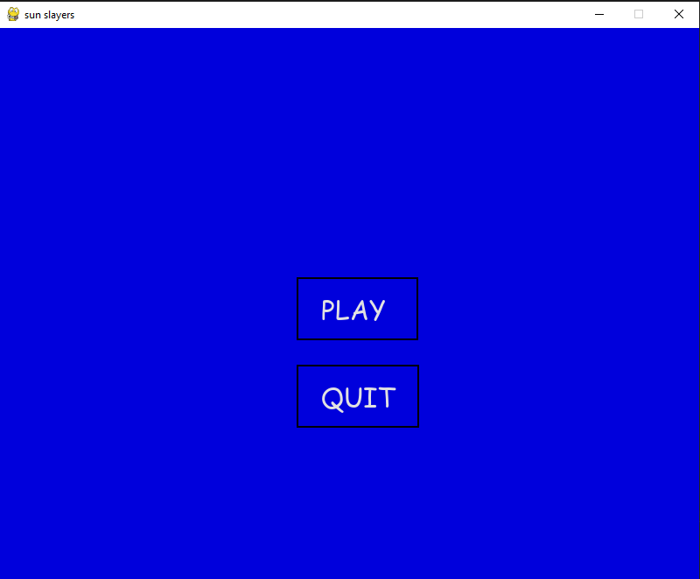
Play button:
This is used for the user interaction so that the player can get into the game, once the player has clicked the play button they will be instantly sent to level 1 to indicate that they are in level 1 it will display level 1

Quit button:
This is usability feature allows the player to quit the game and close it

Level indicator
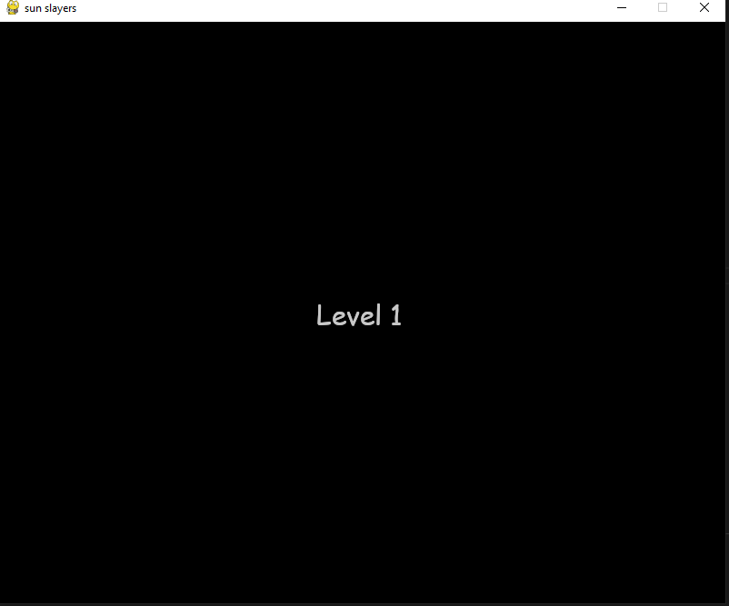
After the player has clicked the play button it will display level 1 to indicate that they are In the game successfully

Level 1
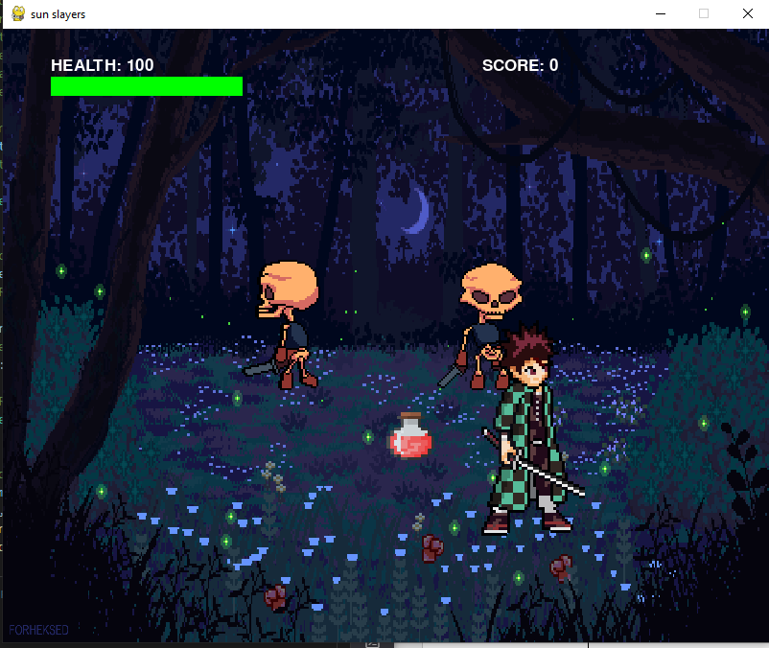

The skeletons are the enemies and the character in the green jacket and sword is the main character/player the job of the player is to kill the skeletons by using the keys e, z and x also the mouse button. I have met the criteria by making it a forest background and I have added a health bar which is functional when the player touches the enemy they lose health points

Animations of the player
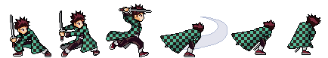

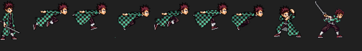

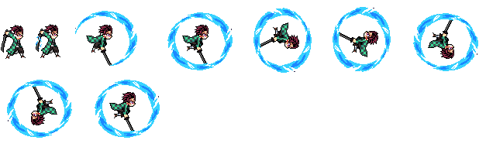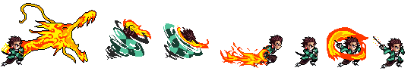
The player has a animations for a lot of movements such as running and fighting

Enemies

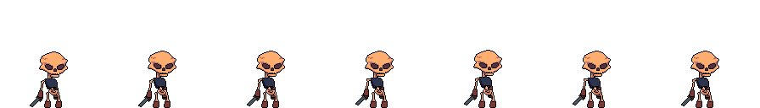

This filed sprite will not be changed until certain conditions are met



If the player is in range, it will try find it and walk towards it.

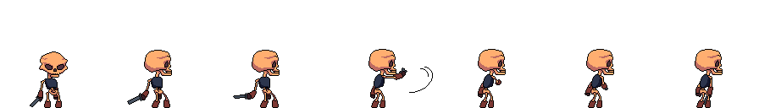
This is the attack file sprite which is activated when the player is in range and is close to its rectangle which I have used with the Pygame rectangle

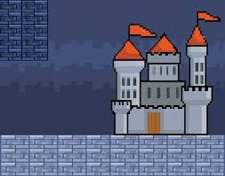
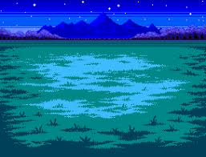

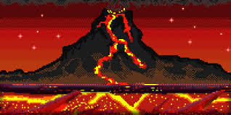
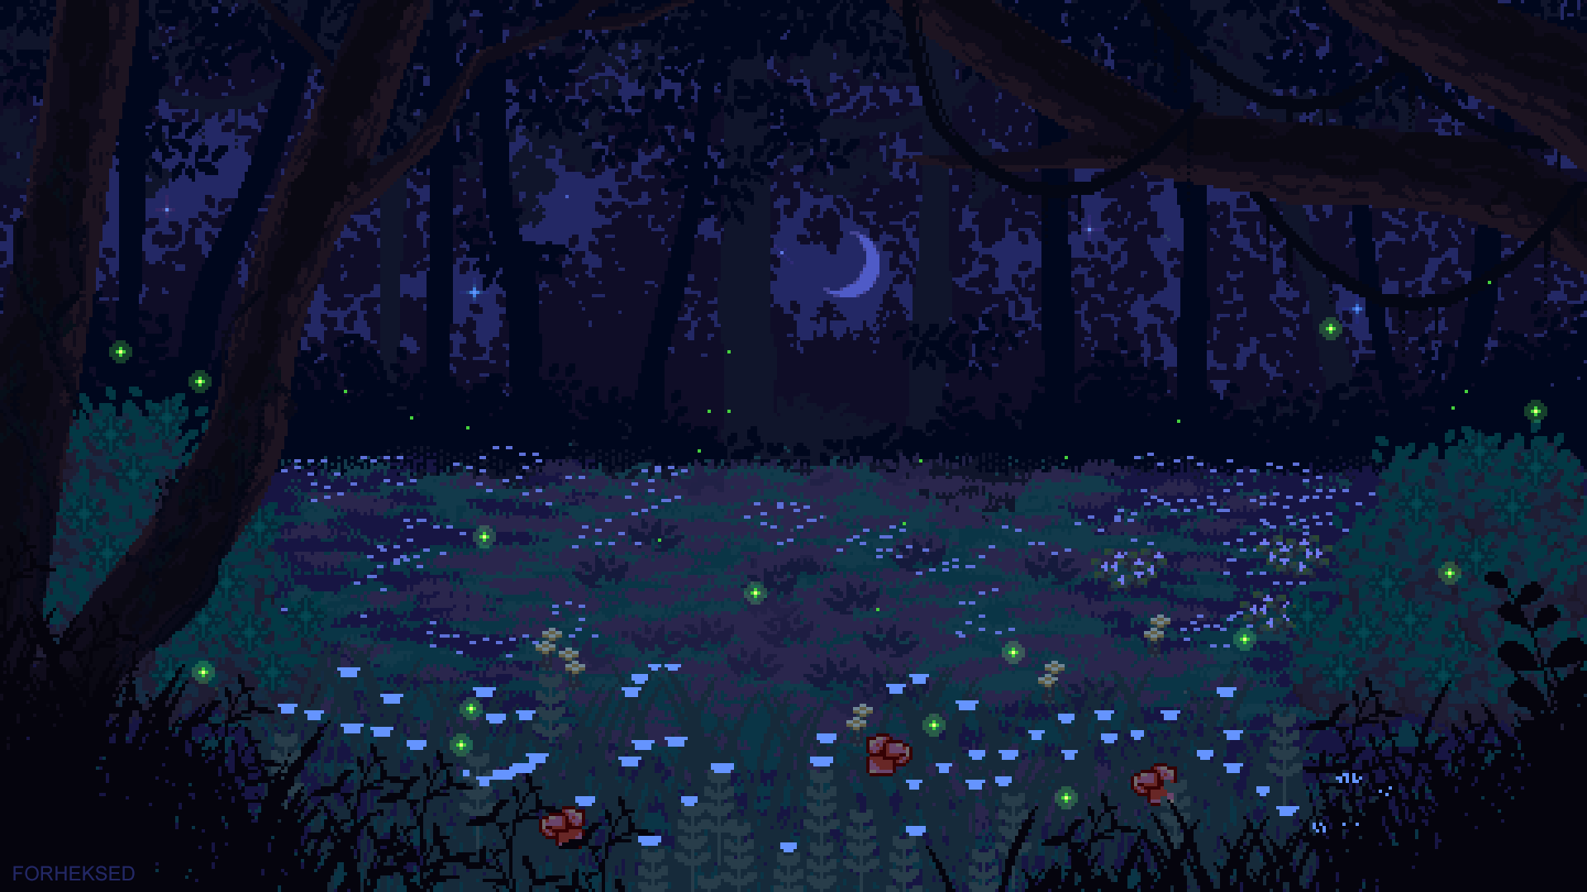

These are the levels sprite files which will switch after the enemies have been killed
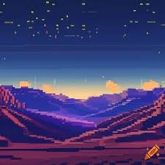

Classes
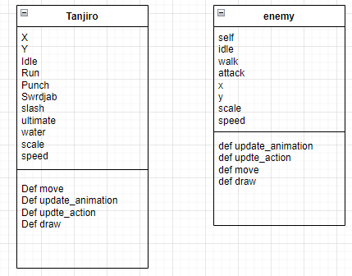

Algorithms
Main menu
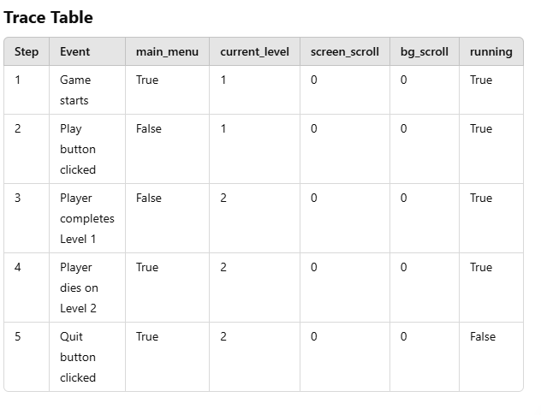
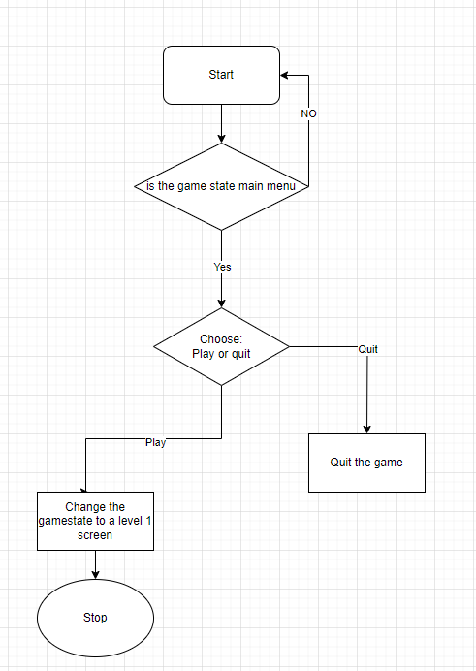
When the user runs the game
Then it goes into the main menu game state
The user will have the options to play and quit
The play button will change the game state, and the main menu will stop
The quit button will shut the game down

Game over:
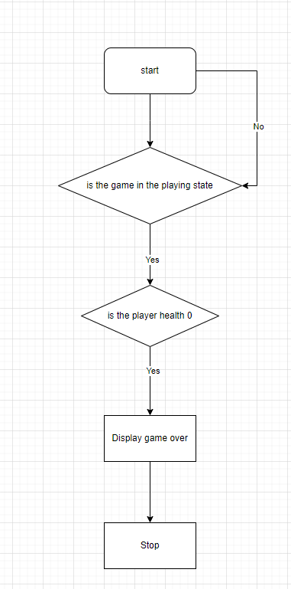
When the game state is in the level states and the player health is 0 then it will display that the game is over then the program will stop

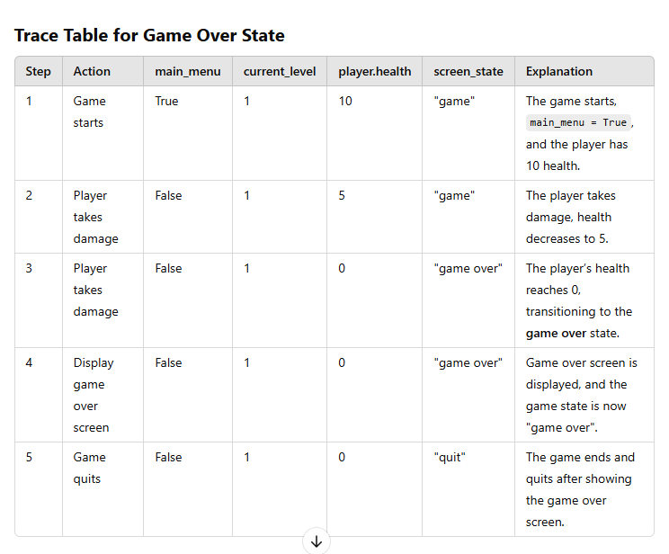

Player Movement
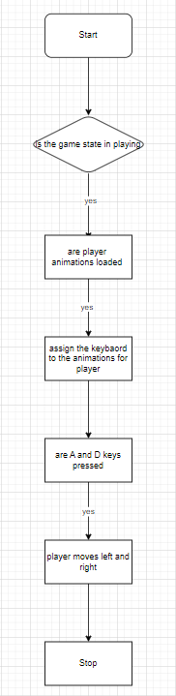
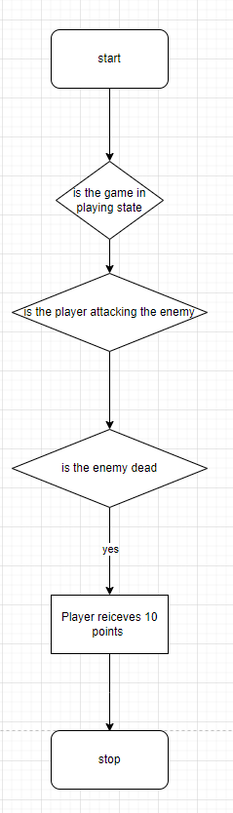
Score

Collectables
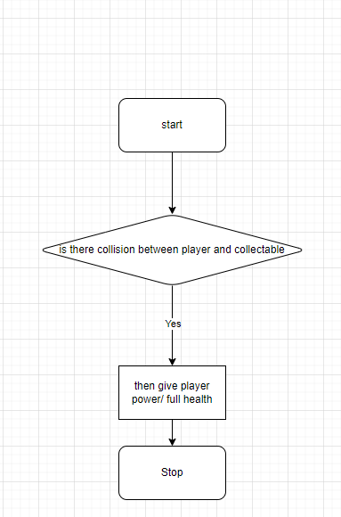

Levels
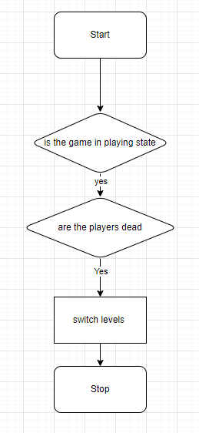

Screen scrolling
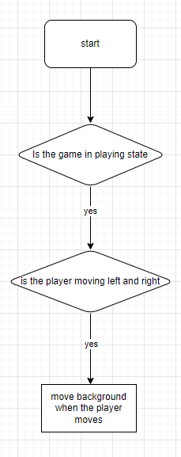

The algorithms bundled up
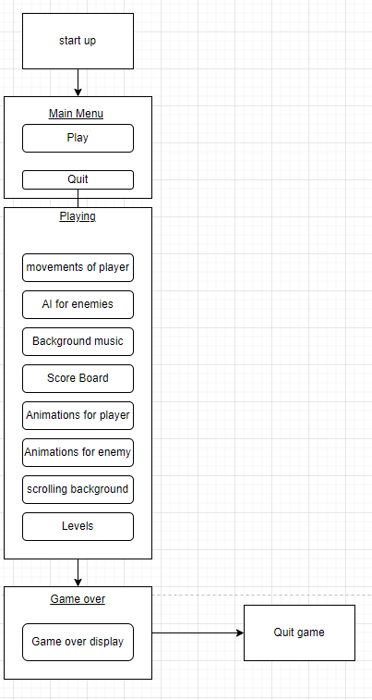

KEY VARIABLES AND DATA STRUCTURE

Main menu class
Method | Name | Data Type | Explanation | Justification
Procedure | Drawmsge | N/A | This is used to draw messages onto the main menu screen I have used for writing the text for the play and quit button | This is the code for creating the text messages
Procedure | playbutton | N/A | This is used to draw the rectangle and the button for the play button and Drawmsge has been used | This is the code for creating the play button
Procedure | Quitbutton | N/A | This is used to draw the rectangle and the button for the quit button and Drawmsge has been used | This is the code for creating the quit button
Procedure | Collision | N/A | This is used to check if the position of the mouse is hovering over the rectangles of the buttons | This is the code for collision between mouse and buttons
Attribute | Screen | Pygame. Surface | This is used to display the surface where the main menu elements are being rendered | This is required for displaying the surface for drawing the menu elements
Attribute | Font | Pygame. Font | It is used for rendering text in the main menu | This is required for actually writing something
Procedure | __init__(self,screen) | N/A | This is a constructor for initializing the menu with a di | It is required for setting up the menu
Attribute | comic_sans | Pygame.font.Font | This is the style of writing which will be displayed | This is required for better and clearer visuals
Attribute | Play_collision | Boolean | This tracks if there is a collision between mouse and the play button | This is important because then it will allow the user to navigate through the game

Levels class
Procedure | Fade text | N/A | This is used to display text with a black screen as a background for a certain period of time | This is the code used for switching levels
Attribute | Menu | N/A | This is used to link the main menu screen with the level screen so they can
Parameter | Duration | Integer | This is used to set how long the level screen will be displayed | This is required for game state switching
Parameter | Msge | String | This is used to display the message on the | It indicates which level the player is on
Parameter | Font | String | This input is used to display the font as an output | Required for visuals
Parameter | Color | String | This input is used to display the color of the message as an output | Required for visuals
Parameters | x,y | Integer | This input is used to display the position of the message as an output | Required for visuals

Main player class
Attribute | Alive | Boolean | Indicates whether the player is alive or not | This is required so that I can use it to give it the death animation and game over
Attribute | Health | Integer | Represents the current health of the player | Important for damages and collectable item
Attribute | Score | Integer | Tracks the players score in the game | Vital for scoring in the game
Attribute | Idle | String | Base name of the idle animation files for the player | Vital for the idle animation
Attribute | Run | String | Base name of the run animation files for the player | Vital for the running animation
Attribute | Punch | String | Base name of the punch animation files for the player | Vital for the punching animation
Attribute | Swrdjab | String | Base name of the sword jab animation files for the player | Vital for the sword jab animation
Attribute | Slash | String | Base name of the slash animation files for the player | Vital for the slash animation
Attribute | Ultimate | String | Base name of the ultimate animation files for the player | Vital for the ultimate animation
Attribute | Char_type_water | String | Base name of the water animation files for the player | Vital for the water animation
Attribute | Speed | Integer | Represents the movement speed of the player | Vital for less delay and promptness
Attribute | Direction | Integer | Tracks the direction of the player | Important for flipping the character and AI movement from enemies
Attribute | Jump | Boolean | Indicates whether the player is jumping | Important for jumping
Attribute | Air | Boolean | Indicates if the player is in the air | Important for setting gravity
Attribute | Flip | Boolean | Determines if the players sprite should be flipped horizontally | Importing for flipping the character
Attribute | Anim_list | List | Stores animation frames for different player actions | Important for the actual display for animations
Attribute | Frame index | Integer | Tracks the current frame index in the animation | Important for displaying which animation file should be displayed first
Attribute | Action | Integer | It represents the current action being performed | Its useful for shortcutting
Attribute | Update_time | Integer | Records the last time the animation frame was updated | Its useful for switching from one animation to another
Attribute | Enemy | Object | Reference to the enemy object for interactions and collision | Useful for dealing damage and taking damage
Attribute | Sprites | Pygame.surface | Stores the current sprite image to be displayed | Useful for displaying the sprite
Attribute | Rect | Pygame.rect | Rectangle for collision detection and sprite positioning | Used for making an invisible box around the sprites so I can use it for collision
Attribute | Pp | Tuple | Represents the position of the players center | Useful for locating the players position
Procedure | Move | N/A | This code is used for moving the character left and right | Useful for player movement and user experience
Procedure | Update_animation | N/A | This code updates the current animation frame based on the player’s action and cooldown | Useful for switching animation to animation
Procedure | Update_action | N/A | Changes the player’s action from action and resets the current animation frame | Useful for key mapping
Procedure | Collision | N/A | Checks for collision with enemies | This is useful for damage and death
Procedure | Collectcol | N/A | This is for the player interaction and collectable item | This is useful for allowing me to add the functions for
Procedure | Damages | N/A | This is the after math of collisions if the conditions are met | This is useful for the health bar
List | Templst | list | This is used for storing the set of animation files within a list | Templst gets integrated into anim_list
Procedure | Healthbar | N/A | This is used for displaying the health bar and the current health | This is important for showing the player how much health is gained and lost and what their current health is at
Procedure | Scoreboard | N/A | This is displaying the score on the screen | Useful for tracking score
Procedure | Draw | N/A | This draws the sprites and when they flip | Important for the visuals

enemy class
Attribute | Ealive | Boolean | This indicates whether or not the enemy is alive or not | Useful for killing the enemy and displaying certain conditions on the screen when the enemy is alive
Attribute | Health | Integer | This indicates the health of the enemy and the health they start of with | This is necessary for killing the enemy
Attribute | Walk | String | Base name of the walk animation files for the enemy | This is so that I can display the walk animation
Attribute | Idle | String | Base name of the idle animation files for the enemy  w | This is so that I can display the walk animation
Attribute | Attack | String | Base name of the animation files3 for the enemy | This is so that I can display the attack animation
Attribute | Speed | String | This is used for fast the enemy moves | Useful for enemy movement
Attribute | Step_lim | String | This is used to determine the maximum number of steps the skeleton can take | Useful so that the enemy does not go too far out or too far in
Attribute | Step counter | String | This is used to count how many steps the enemy has made | Useful for tracking the enemies step
Attribute | Dead | String | Base name of the death animation files for the enemy | This is so that I can display the death animation
Attribute | Direction | Integer | I use this so then I can determine which direction the enemy is face if its 1 then it faces to the right if its -1 it faces to the left | Useful for the AI movement
Attribute | Flip | Boolean | This is set to false because it will only be activated when the enemy has taken a certain number of steps or when it needs to track the enemy for collision | Useful for visuals and dealing damage
Attribute | Anim_list | List | Stores animation frames for the different enemy actions | Useful for animations
Attribute | Frame_index | Integer | Tracks the current index in the animation | Useful for animations
Attribute | Update_time | Integer | Records the last time the animation frame was updated | Useful for animations
Attribute | Rect | Pygame.rect | I am using Rectangles for collision detection and sprite | Useful for visuals and game mechanics
Procedure | Move | N/A | This handles the enemy movement and its direction | Vital for movement and AI
Procedure | Update_animations | N/A | Updates the enemy’s current animation frame which is based on its action and cooldowns | Vital for updating the animation
Procedure | Take_damage | N/A | Reduces the enemies health by a specified amount and checks if it dies | This is important for death
Procedure | Check_collision | N/A | This tracks and detects if the player and enemy have collided | This is important so then we can see that they have interacted and dealt damage to each other

collectables class
Attribute | Self.x | Integer | The x-coordinates holds the collectables horizontal position in the game | Useful for placing the collectable in the game
Attribute | Self.y | Integer | The y-coordinates holds the collectables vertical position in the game | Useful for placing the collectable in the game
Attribute | Type | String | Indicates the type of collectable | Useful for selection
Attribute | Collected | Boolean | Tracks if the collectable has been picked up by the player | Useful for removing the collectable from the screen
Procedure | Draw | N/A | Draws the collectable on the specified screen if it has not been collected | Useful for displaying the collectable
Procedure | Check_collison | N/A | This code detects collision with the player and collectable | Useful for collision
Procedure | Apply_effect | N/A | Applies the collectable’s effect | This is will cause the player to get its health back and power

global variables and methods
Variables | scrn_width | Integer | Sets the width of the game screen. | Needed to define the game display size.
Variables | scrn_height | Integer | Sets the height of the game screen, proportional to scrn_width | Ensures proper aspect ratio for the game window.
Variables | screen | pygame.Surface | Stores the game window surface | Required for rendering all visual elements in the game.
Variables | clock | pygame.time.Clock | Manages the game's frame rate. | Ensures the game runs at a consistent speed.
constant | FPS | Integer | Sets the frames per second for the game. | Maintains smooth gameplay by capping the frame rate.
Constant | gravity | Float | Gravity constant used in physics calculations for movement. | Simulates realistic movement for characters and objects
Constant | scroll_limit | Integer | Defines the threshold for scrolling the background. | Prevents the player from scrolling the background indefinitely.
Constant | rows | Integer | Number of rows in the game grid. | Helps define the grid for levels or maps.
constant | cols | Integer | Number of columns in the game grid | Ensures large horizontal space for game levels.
constant | screen_scroll | Integer | Tracks the background scrolling speed. | Used to scroll the game world as the player moves.
Variables | bg_scroll | Integer | Stores the player's starting position as [x, y]. | Ensures the background scrolls in sync with the player's movement.
Variables | p_positon | list | Stores the player's starting position as [x, y]. | Needed to initialize the player's location in the game world.
Variables | camera | list | Tracks the camera’s offset in [x, y]. | Used to follow the player and adjust the view dynamically.
Variables | move_lft | Boolean | Tracks if the player is moving left. | Enables directional input for player movement.
Variables | move_rgt | Boolean | Tracks if the player is moving right. | Enables directional input for player movement
Variables | rgt_clck | Boolean | Tracks if the right mouse button is clicked. | Enables interactions using the right mouse button.
Variables | lft_clck | Boolean | Tracks if the right mouse button is clicked. | Enables interactions using the left mouse button.
Variables | e | Boolean | Tracks if the E key is pressed | Enables specific actions or interactions in the game.
Variables | Z | Boolean | Tracks if the Z key is pressed. | Enables specific actions or interactions in the game.
Variables | x | Boolean | Tracks if the X key is pressed. | Enables specific actions or interactions in the game.
Variables | main_menu | Boolean | Indicates if the game is in the main menu state. | Allows switching between menu and gameplay states.

Test data
Main menu:
Input/Action | Expected output | Actual Output | Pass/fail
Launch game | Main menu appears with the play and quit buttons | Main menu appears correctly | Pass
Hover over play button | Button highlights feedback | No button highlights | Fail
Hover over quit button | Button highlights feedback | No button highlights | Fail
Click play button | Game transition to the first level or gameplay | Game transition | Pass
Click quit button | Game closes | Game closes as expected | pass
Player Movement:
Input/Action | Expected output | Actual Output | Pass/fail
Press A key | Player moves left | Player moves left | Pass
Press D key | Player moves right | Player moves right | Pass
Press space bar | Player jumps | Player jumps | Pass
Press A + space bar | Player jumps left | Player jumps left | Pass
Press D + space bar | Player jumps right | Player jumps right | Pass
Scoring system
Input/Action | Expected output | Actual Output | Pass/fail or both
Defeat an enemy | Score increases | Two enemies die but the player receives a score of 10 for both enemies | Both

Health system:
Input/Action | Expected output | Actual Output | Pass/fail or both
Player hit by enemy attack | Health decreases by 1 per attack while its in range | Players health gets reduced by 1 | Pass
Health potion collected | Health goes back to 100 if its not already on 100 | Player receives full health | pass
Player idle Animation
Input/Action | Expected output | Actual Output | Pass/fail or both
Player remains stationary | Idle animation the player should be standing still | Idle animations plays correctly | Pass
Movement animations
Input/Action | Expected output | Actual Output | Pass/fail or both
Press A key | running animation plays and moves left | It moves left with the running animation | Fail
Press D key | running animation plays and moves right | It moves right with the running animation | fail
Attack Animations
Input/Action | Expected output | Actual Output | Pass/fail or both
Press right mouse button | Slash animation should be displayed | Slash animation is not displayed | Fail
Press x key | Water roll animation should be displayed | Water roll animation is not displayed is displayed | Fail
Press z key | Fire dragon animation should be displayed | It is not displayed | Fail
Press e | The punch animation should be displayed | It is not displayed | Fail

AI detection
Input/Action | Expected output | Actual Output | Pass/fail or both
enemy attacking when the player is in | Enemy attacks the player when its in range | Enemy does attack the player when its in range | Pass
Enemy follows the player when it has gone in range | Enemy should follow the player | Enemy does follow the player | pass
Enemy animation
Input/Action | Expected output | Actual Output | Pass/fail or both
Enemy Ai walk | Walk animation should be displayed | Walk animation is displayed | Pass
Enemy AI attack | Attack animation should be displayed | Attack animation is displayed | Pass
Enemy AI death | Death animation should be displayed | It is not displayed | fail

Developing the coded solution (“The development story”)

Sprite creation

Date: 10/08/2024
I wanted to get the sprites and their animations ready before I started programming the coded solution. I found the sprites with some research on the internet, I had searched for tanjiro sprites, background images. In order to get the sprite to animate I had to break up each frame using gimp studio. Then I had to remove its background because It was getting in the way when it was being displayed on the Gui
Finaly I have stored all the sprites required in an organised file
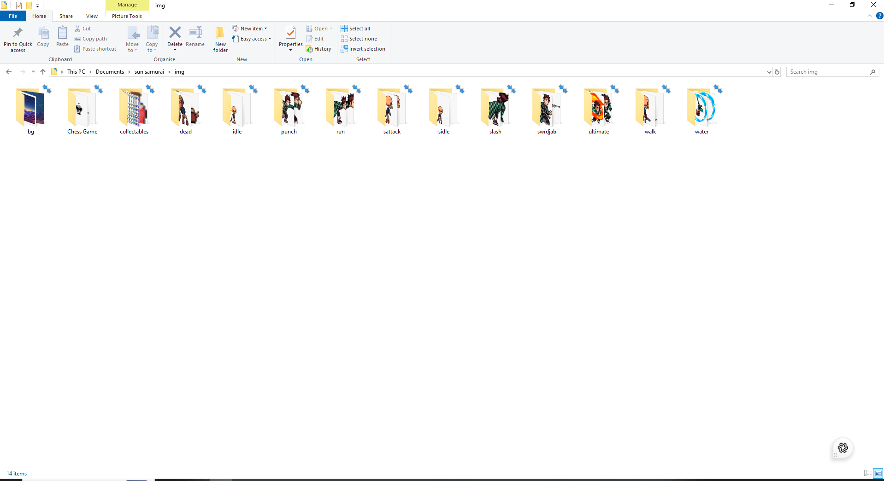

code deconstruction

date: 29/09/2024
For this section I will go through my code solution and how I developed it. The development will be shown in a sequence of screen shots.
To get a kickstart in the coding I went on YouTube to research a platformer game and how they made it
The link for the tutorial:

https://www.youtube.com/watch?v=DHgj5jhMJKg&list=PLjcN1EyupaQm20hlUE11y9y8EY2aXLpnv
Structure

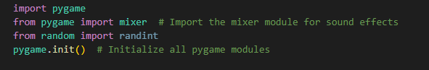

Pygame is a library of functions for creating 2D games the command import is putting Pygame into the the code so we can use its features and functions

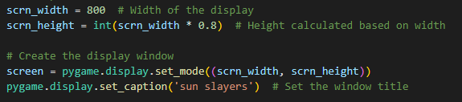
These codes are used to set the screen size and to set the caption of the GUI as well displaying everything


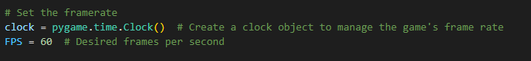


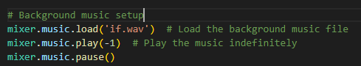



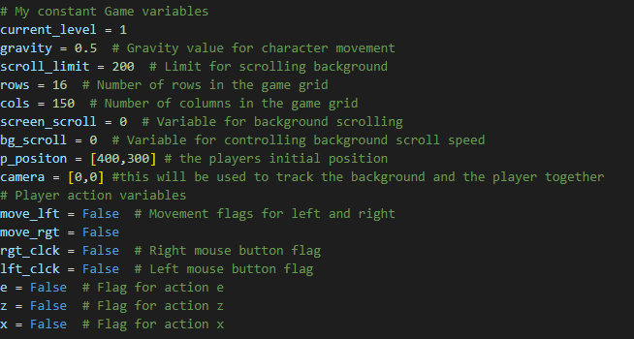


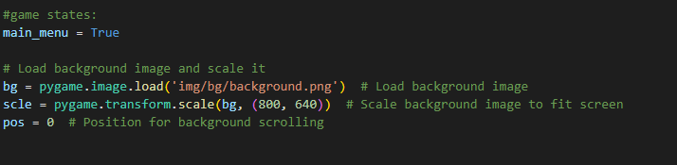

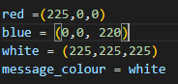


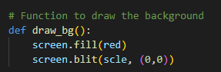

<See H446-03 Project Advice Booklet for help and guidance of what must go here.>



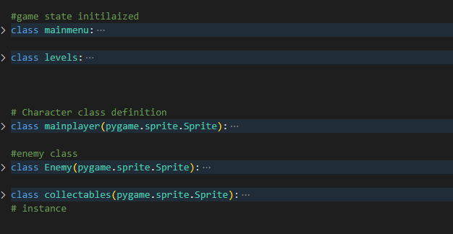



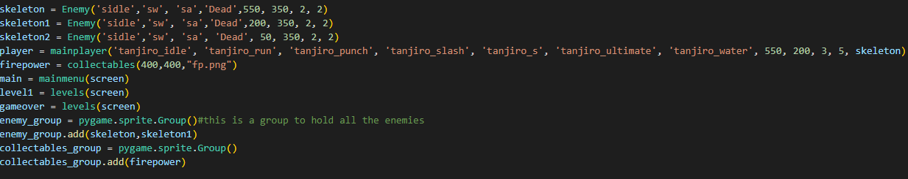


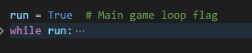

D. Evaluation

<See H446-03 Project Advice Booklet for help and guidance of what must go here.>

Project Appendixes
Insert as many project appendixes as you need for your project.
These might include, but are not limited to:
- Complete Code Listing (ESSENTIAL)
- Interview Transcripts
- Meeting notes
- Observation notes or questionnaires
- import pygame
- from pygame import mixer # Import the mixer module for sound effects
- from random import randint
- pygame.init() # Initialize all pygame modules

- # Set up screen dimensions
- scrn_width = 800 # Width of the display
- scrn_height = int(scrn_width * 0.8) # Height calculated based on width

- # Create the display window
- screen = pygame.display.set_mode((scrn_width, scrn_height))
- pygame.display.set_caption('sun slayers') # Set the window title

- # Set the framerate
- clock = pygame.time.Clock() # Create a clock object to manage the game's frame rate
- FPS = 60 # Desired frames per second

- # Background music setup
- mixer.music.load('if.wav') # Load the background music file
- mixer.music.play(-1) # Play the music indefinitely
- mixer.music.pause()
- # My constant Game variables
- current_level = 1
- gravity = 0.5 # Gravity value for character movement
- scroll_limit = 200 # Limit for scrolling background
- rows = 16 # Number of rows in the game grid
- cols = 150 # Number of columns in the game grid
- screen_scroll = 0 # Variable for background scrolling
- bg_scroll = 0 # Variable for controlling background scroll speed
- p_positon = [400,300] # the players initial position
- camera = [0,0] #this will be used to track the background and the player together
- # Player action variables
- move_lft = False # Movement flags for left and right
- move_rgt = False
- rgt_clck = False # Right mouse button flag
- lft_clck = False # Left mouse button flag
- e = False # Flag for action e
- z = False # Flag for action z
- x = False # Flag for action x

- #game states:
- main_menu = True

- # Load background image and scale it
- bg = pygame.image.load('img/bg/background.png') # Load background image
- scle = pygame.transform.scale(bg, (800, 640)) # Scale background image to fit screen
- pos = 0 # Position for background scrolling

- red =(225,0,0)
- blue = (0,0, 220)
- white = (225,225,225)
- message_colour = white

- # Function to draw the background
- def draw_bg():
- screen.fill(red)
- screen.blit(scle, (0,0))

- #game state initilaized
- class mainmenu:
- def __init__(self, screen):
- self.screen = screen
- self.font = pygame.font.Font(None, 36)

- pos = 0
- comic_sans = pygame.font.SysFont("comic sans MS", 30)
- def drawmsge(self, msge, comic_sans,message_colour, x,y): # this will display the message on the main menu screen so like play now
- img = comic_sans.render(msge, True, message_colour)
- img_rect = img.get_rect(topleft=(x, y))
- return img, img_rect

- def playbutton(self):
- white = (225,225,225)
- img,img_rectangle = self.drawmsge(" PLAY ", self.comic_sans, white, 350,300)
- play_rectangle = img_rectangle.inflate(20, 30)# this is used to create a bigger rectangle than the orginal rectangle so
- pygame.draw.rect(self.screen, (0, 0, 0), play_rectangle, 2)
- screen.blit(img, img_rectangle)

- return play_rectangle
- def quitbutton(self):
- white = (225,225,225)
- img,img_rectangle = self.drawmsge(" QUIT ", self.comic_sans, white, 350,400)
- quit_rectangle = img_rectangle.inflate(20, 30)# this is used to create a bigger rectangle than the orginal rectangle so
- pygame.draw.rect(self.screen, (0, 0, 0), quit_rectangle, 2)
- screen.blit(img, img_rectangle)
- return quit_rectangle

- def collision(self):
- play_rectangle = self.playbutton()
- quit_rectangle = self.quitbutton()
- mouse_pos = pygame.mouse.get_pos()
- self.play_collision = play_rectangle.collidepoint(mouse_pos)
- if self.play_collision == True:
- pygame.draw.rect(self.screen, (0, 0, 0, 100), play_rectangle)
- quit_rectangle = quit_rectangle.collidepoint(mouse_pos)
- if quit_rectangle == True:
- pygame.draw.rect(self.screen, (0, 0, 0, 100), quit_rectangle)

- class levels:
- def __init__(self, screen):
- self.screen = screen
- self.menu = main_menu

- def faded_text(self, duration ,msge, comic_sans,message_colour, x,y):
- fade_surface = pygame.Surface((scrn_width, scrn_height))
- fade_surface.fill((0,0,0)) #filling the screen with black
- text = comic_sans.render(msge, True, message_colour)
- # this is used for how long the screen will be black for
- start = pygame.time.get_ticks()
- end = 0

- while end < duration:
- end = pygame.time.get_ticks() - start
- transparent = min(255, int((end/duration) *255))
- fade_surface.set_alpha(transparent)
- self.screen.blit(fade_surface, (0,0))
- self.screen.blit(text, (x,y))
- pygame.display.update()
- pygame.time.wait(10)

- # Character class definition
- class mainplayer(pygame.sprite.Sprite):
- def __init__(self, idle, run, punch, swrdjab, slash, ultimate, water, x, y, scale, speed, Enemy):
- pygame.sprite.Sprite.__init__(self) # Initialize the parent Sprite class
- # Initialize character type attributes
- self.alive = True
- self.health = 100 #limit of health points
- self.start_health = 100 # the starting health
- self.score = 0
- self.idle = idle
- self.run = run
- self.punch = punch
- self.swrdjab = swrdjab
- self.slash = slash
- self.ultimate = ultimate
- self.char_type_water = water
- self.speed = speed # Set the character's speed
- self.direction = 1 # Direction the character is facing
- self.jump = False
- self.air = True
- self.velocitY = 0
- self.flip = False # Flip attribute for character sprite
- self.anim_list = [] # List to hold different animations
- self.frame_index = 0 # Current frame index for animation
- self.action = 0 # Current action of the character
- self.update_time = pygame.time.get_ticks() # Initialize the update time
- self.Enemy = Enemy
- # Load idle animation
- templst = [] # Temporary list for animation frames
- for i in range(2):
- sprites = pygame.image.load(f'img/idle/{self.idle}{i}.png') # Load idle sprites
- sprites = pygame.transform.scale(sprites, (sprites.get_width() * scale, sprites.get_height() * scale)) # Scale the sprite
- pygame.Surface.convert_alpha(sprites) # Convert surface for transparency
- templst.append(sprites) # Add sprite to the temporary list
- self.anim_list.append(templst) # Add idle animation list to the main animation list

- # Load run animation
- templst = [] # Reset temporary list
- for i in range(6):
- sprites = pygame.image.load(f'img/run/{self.run}{i}.png') # Load run sprites
- sprites = pygame.transform.scale(sprites, (sprites.get_width() * scale, sprites.get_height() * scale)) # Scale the sprite
- templst.append(sprites) # Add sprite to the temporary list
- self.anim_list.append(templst) # Add run animation list to the main animation list

- # Load punch animation
- templst = [] # Reset temporary list
- for i in range(2):
- sprites = pygame.image.load(f'img/punch/{self.punch}{i}.png') # Load punch sprites
- sprites = pygame.transform.scale(sprites, (sprites.get_width() * scale, sprites.get_height() * scale)) # Scale the sprite
- templst.append(sprites) # Add sprite to the temporary list
- self.anim_list.append(templst) # Add punch animation list to the main animation list

- # Load sword jab animation
- templst = [] # Reset temporary list
- for i in range(2):
- sprites = pygame.image.load(f'img/swrdjab/{self.swrdjab}{i}.png') # Load sword jab sprites
- sprites = pygame.transform.scale(sprites, (sprites.get_width() * scale, sprites.get_height() * scale)) # Scale the sprite
- templst.append(sprites) # Add sprite to the temporary list
- self.anim_list.append(templst) # Add sword jab animation list to the main animation list

- # Load slash animation
- templst = [] # Reset temporary list
- for i in range(6):
- sprites = pygame.image.load(f'img/slash/{self.slash}{i}.png') # Load slash sprites
- sprites = pygame.transform.scale(sprites, (sprites.get_width() * scale, sprites.get_height() * scale)) # Scale the sprite
- templst.append(sprites) # Add sprite to the temporary list
- self.anim_list.append(templst) # Add slash animation list to the main animation list

- # Load ultimate animation
- templst = [] # Reset temporary list
- for i in range(7):
- sprites = pygame.image.load(f'img/ultimate/{self.ultimate}{i}.png') # Load ultimate sprites
- sprites = pygame.transform.scale(sprites, (sprites.get_width() * scale, sprites.get_height() * scale)) # Scale the sprite
- templst.append(sprites) # Add sprite to the temporary list
- self.anim_list.append(templst) # Add ultimate animation list to the main animation list

- # Load water animation
- templst = [] # Reset temporary list
- for i in range(9):
- sprites = pygame.image.load(f'img/water/{self.char_type_water}{i}.png') # Load water sprites
- sprites = pygame.transform.scale(sprites, (sprites.get_width() * scale, sprites.get_height() * scale)) # Scale the sprite
- templst.append(sprites) # Add sprite to the temporary list
- self.anim_list.append(templst) # Add water animation list to the main animation list

- # Initialize sprite and rectangle for collision detection
- self.sprites = self.anim_list[self.action][self.frame_index] # Set the initial sprite
- self.rect = self.sprites.get_rect() # Create a rectangle around the sprite for positioning
- self.pp = self.rect.center = (x, y) # Set the rectangle's center position

- def move(self, move_rgt, move_lft):
- dx = 0 # Change in x position
- dy = 0 # Change in y position

- # Check for left movement
- if move_lft:
- dx = -self.speed # Move left
- self.flip = True # Flip the sprite for left movement
- self.direction = -1 # Update direction
- # Check for right movement
- if move_rgt:
- dx = self.speed # Move right
- self.flip = False # No flip for right movement
- self.direction = 1 # Update direction

- if self.jump == True and self.air == False:
- self.velocitY = -15
- self.jump = False

- #adding gravity so my player doesnt just fly off the screen
- self.velocitY += gravity
- if self.velocitY > 10:
- self.velocitY
- dy += self.velocitY

- if self.rect.bottom + dy > 550:
- dy = 550 - self.rect.bottom
- self.air = False

- # Update rectangle position based on movement
- self.rect.x += dx
- self.rect.y += dy
- global screen_scroll
- #camera tracker
- #if self.pp :
- #if self.rect.right > scrn_width - scroll_limit or self.rect.left < scrn_width + scroll_limit:
- #self.rect.x -= dx
- #screen_scroll = -dx

- return screen_scroll
- def update_animation(self):
- # Update animation based on action
- anim_cldwn = 120 # Default animation cooldown
- if self.action == 2: # Punch action
- anim_cldwn = 10 # Faster cooldown for punch
- elif self.action == 3: # Sword jab action
- anim_cldwn = 10 # Faster cooldown for sword jab
- elif self.action == 5: # Ultimate action
- anim_cldwn = 100 # Slower cooldown for ultimate
- elif self.action == 4: # Slash action
- anim_cldwn = 100 # Faster cooldown for slash

- # Update current sprite depending on the action and frame index
- self.sprites = self.anim_list[self.action][self.frame_index] # Get the current sprite
- # Check if it's time to update the frame
- if pygame.time.get_ticks() - self.update_time > anim_cldwn:
- self.update_time = pygame.time.get_ticks() # Reset the update time
- self.frame_index += 1 # Move to the next frame

- # Reset frame index if it exceeds the number of frames for the current action
- if self.frame_index >= len(self.anim_list[self.action]):
- self.frame_index = 1 # Reset to the second frame to loop the animation

- def updte_action(self, new_action):
- # Change action if it's different from the current one
- if new_action != self.action:
- self.action = new_action # Update to new action
- self.frame_index = 0 # Reset frame index to the first frame
- self.update_time = pygame.time.get_ticks() # Reset update time

- def collision(self, enemy):
- # Check collision with platforms
- if self.rect.colliderect(enemy.rect):
- if self.action in [2,4,5,6]:
- skeleton.updte_action(3)
- skeleton1.updte_action(3)

- enemy_group.remove(skeleton,skeleton1) # This code indicates which animations cause a collision effect on the enemy so I have just added the attack animations from the main player to the enemy so it dies
- print('enemy is dead')
- def collectcol(self, collectables):
- if self.rect.colliderect(collectables.rect):
- if self.action:
- self.health = 100 # if the player collides with this their health will go to to 100 no matter what health they are currently at
- print('there is a collision for power ups')
- collectables_group.remove(firepower)

- def damages(self, enemy):
- # deal damaage to the enemy
- if self.rect.colliderect(enemy.rect) :
- if self.action in [2,4,5,6]:
- skeleton.health -= 10

- print('enemy is damaged')
- if skeleton.health <= 0:
- self.score = 10
- skeleton.updte_action(3)
- enemy_group.remove(skeleton)
- skeleton1.health -= 10

- print('enemy is damaged')
- if skeleton1.health <= 0:
- self.score = 10
- skeleton1.updte_action(3)
- enemy_group.remove(skeleton1)
- # deal damage to the player
- if self.rect.colliderect(enemy.rect):
- if self.action in [1,2,4,5,6]:
- self.health -= 1
- print('player is damaged')

- def healthbar(self, x,y, current_health):
- bar_width = 200 # size
- bar_height = 20 # size
- current_health = max(0, self.health )
- fill_width = (current_health/self.start_health)* bar_width #shows the aftermath of getting hit by the enemy
- bar_dim = pygame.Rect(x,y, bar_width, bar_height)
- fill_bar_colour = pygame.Rect(x,y, fill_width, bar_height)
- # displaying the bar and its colour
- pygame.draw.rect(screen, (255,0,0), bar_dim) #starting health
- pygame.draw.rect(screen, (0,255,0), fill_bar_colour) # once hit shows red
- # drawing the health text to indicate what they start with and their current
- font = pygame.font.Font(None, 25)
- htext = font.render(f'HEALTH: {current_health}', True, (255,255,255))
- screen.blit(htext, (x, y - 20)) # displays text above the health bar
- def scoreboard(self, x,y):
- # display the score
- font = pygame.font.Font(None, 25)
- score_text = font.render(f'SCORE: {self.score}', True, (255,255,255))
- screen.blit(score_text,(x,y - 20))

- def draw(self):
- # Draw the current sprite on the screen
- screen.blit(pygame.transform.flip(self.sprites, self.flip, False), self.rect) # Flip sprite if needed

- #enemy class
- class Enemy(pygame.sprite.Sprite):
- def __init__(self, idle, walk, attack, dead, x, y, scale ,speed, steps_limit=50):
- pygame.sprite.Sprite.__init__(self)
- self.Ealive = True
- self.health = 50
- self.walk = walk #constructor for calling images from their paths
- self.idle = idle
- self.attack = attack
- self.speed = speed
- self.step_lim = steps_limit # this is the maximum amount of steps the enemy can take before flipping
- self.step_counter = 0 # this is used for counting how many steps the enemy takes before it flips
- self.dead = dead
- self.direction = 1
- self.flip = False
- self.anim_list = []
- self.action = 0
- self.frame_index = 0
- self.update_time = pygame.time.get_ticks()

- # Load idle animation
- #idle
- templst = [] # Temporary list for animation frames
- for i in range(1):
- sprites = pygame.image.load(f'img/sidle/{self.idle}{i}.png') # Load idle sprites
- sprites = pygame.transform.scale(sprites, (sprites.get_width() * scale, sprites.get_height() * scale)) # Scale the sprite
- pygame.Surface.convert_alpha(sprites) # Convert surface for transparency
- templst.append(sprites) # Add sprite to the temporary list
- self.anim_list.append(templst) # Add idle animation list to the main animation list

- # Load walk animation
- #walk
- templst = [] # Temporary list for animation frames
- for i in range(8):
- sprites = pygame.image.load(f'img/walk/{self.walk}{i}.png') # Load idle sprites
- sprites = pygame.transform.scale(sprites, (sprites.get_width() * scale, sprites.get_height() * scale)) # Scale the sprite
- pygame.Surface.convert_alpha(sprites) # Convert surface for transparency
- templst.append(sprites) # Add sprite to the temporary list
- self.anim_list.append(templst) # Add idle animation list to the main animation list
- # Load idle animation
- #attack
- templst = [] # Temporary list for animation frames
- for i in range(6):
- sprites = pygame.image.load(f'img/sattack/{self.attack}{i}.png') # Load idle sprites
- sprites = pygame.transform.scale(sprites, (sprites.get_width() * scale, sprites.get_height() * scale)) # Scale the sprite
- pygame.Surface.convert_alpha(sprites) # Convert surface for transparency
- templst.append(sprites) # Add sprite to the temporary list
- self.anim_list.append(templst) # Add idle animation list to the main animation list

- templst = [] # Temporary list for animation frames
- for i in range(3):
- sprites = pygame.image.load(f'img/Dead/{self.dead}{i}.png') # Load dead sprites
- sprites = pygame.transform.scale(sprites, (sprites.get_width() * scale, sprites.get_height() * scale)) # Scale the sprite
- pygame.Surface.convert_alpha(sprites) # Convert surface for transparency
- templst.append(sprites) # Add sprite to the temporary list
- self.anim_list.append(templst) # Add idle animation list to the main animation list

- # Initialize sprite and rectangle for collision detection
- self.image = self.anim_list[self.action][self.frame_index] # Set the initial sprite
- self.rect = self.image.get_rect() # Create a rectangle around the sprite for positioning
- self.rect.center = (x, y) # Set the rectangle's center position

- def update_animation(self):
- # Set animation cooldown
- anim_cldwn = 100
- # Update current sprite
- self.sprites = self.anim_list[self.action][self.frame_index]
- # Check if it's time to update the frame
- if pygame.time.get_ticks() - self.update_time > anim_cldwn:
- self.update_time = pygame.time.get_ticks()
- self.frame_index += 1
- # Reset frame index if it exceeds the number of frames
- if self.frame_index >= len(self.anim_list[self.action]):
- if self.action == 3: # If the action is "dead," stop at the last frame
- self.frame_index = len(self.anim_list[self.action]) - 1
- else:
- self.frame_index = 0 # Reset for looping animations
- self.image = self.anim_list[self.action][self.frame_index]
- def updte_action(self, new_action):
- # Change action if it's different from the current one
- if new_action != self.action:
- self.action = new_action # Update to new action
- self.frame_index = 0 # Reset frame index to the first frame
- self.update_time = pygame.time.get_ticks() # Reset update time

- def move(self):
- self.rect.x += self.speed * self.direction
- self.step_counter += 1

- if self.step_counter >= self.step_lim:
- self.direction *= -1
- self.flip = not self.flip
- self.step_counter = 0 # reset counter

- def ai(self,player):
- if self.Ealive:
- distance_from_player = abs(self.rect.x - player.rect.x)
- attack_range = 100
- if distance_from_player < attack_range:
- self.updte_action(2) # Change action to attack
- print("enemy has attacked")
- else:
- if self.rect.centerx < player.rect.centerx:
- self.direction = 1
- else:
- self.direction = -1
- self.move()
- self.updte_action(1)

- def update(self, player):
- self.update_animation()
- self.ai(player)

- def draw(self):
- # Draw the current sprite on the screen
- screen.blit(pygame.transform.flip(self.image, self.flip, False), self.rect) # Flip sprite if needed

- class collectables(pygame.sprite.Sprite):
- def __init__(self, x, y, image):
- pygame.sprite.Sprite.__init__(self)
- self.image = pygame.image.load(f'img/collectables/{image}')
- self.rect = self.image.get_rect()
- self.rect.x = x
- self.rect.y = y
- def load_image(self,):

- image = pygame.transform.scale(self.image,(50,50))
- screen.blit(image, (self.rect.x, self.rect.y))
- # instance

- skeleton = Enemy('sidle','sw', 'sa','Dead',550, 350, 2, 2)
- skeleton1 = Enemy('sidle','sw', 'sa','Dead',200, 350, 2, 2)
- skeleton2 = Enemy('sidle','sw', 'sa', 'Dead', 50, 350, 2, 2)
- player = mainplayer('tanjiro_idle', 'tanjiro_run', 'tanjiro_punch', 'tanjiro_slash', 'tanjiro_s', 'tanjiro_ultimate', 'tanjiro_water', 550, 200, 3, 5, skeleton)
- firepower = collectables(400,400,"fp.png")
- main = mainmenu(screen)
- level1 = levels(screen)
- gameover = levels(screen)
- enemy_group = pygame.sprite.Group()#this is a group to hold all the enemies
- enemy_group.add(skeleton,skeleton1)
- collectables_group = pygame.sprite.Group()
- collectables_group.add(firepower)

- run = True # Main game loop flag
- while run:
- clock.tick(FPS) # Control the frame rate
- # game state implemented
- if main_menu == True:
- screen.fill(blue)
- #draw the main menu buttons
- play_rect= main.playbutton()
- quit_rect= main.quitbutton()
- #the positions of the mouse
- mouse_position = pygame.mouse.get_pos()
- #making this variable for calling it quicker
- # making my variables
- pcol = play_rect.collidepoint(mouse_position)
- pressplay = pygame.mouse.get_pressed()[0]
- qcol = quit_rect.collidepoint(mouse_position)
- pressquit = pygame.mouse.get_pressed()[0]
- if pcol:
- pygame.draw.rect(screen,(0,0,0, 100), play_rect)
- if pressplay == True:
- main_menu = False
- if not main_menu:

- level1.faded_text(900, "Level 1", pygame.font.SysFont("comic sans", 30), (200, 200, 200), 350, 300)

- if qcol:
- pygame.draw.rect(screen,(0,0,0, 100), quit_rect)
- if pressquit == True:
- run = False

- else:

- draw_bg()

- for enemy in enemy_group:
- skeleton.update(player)
- skeleton.draw()
- skeleton1.update(player)
- skeleton1.draw()

- #tanjiro instance
- player.draw() # Draw the player character
- player.healthbar(50,50,1000)
- player.scoreboard(500,50)
- player.update_animation() # Update the player's animation
- player.damages(skeleton1)
- player.damages(skeleton)
- player.collectcol(firepower)
- screen_scroll = player.move(move_rgt, move_lft) # Move the player based on input
- firepower.load_image()

- if player.health == 0:
- gameover.faded_text(900, "game over", pygame.font.SysFont("comic sans", 30), (200, 200, 200), 350, 300)

- if len(enemy_group) == 0: # if enemies have been removed then switch to next level
- if current_level ==1:
- current_level = 2
- level1.faded_text(900,"Level 2", pygame.font.SysFont('comic sans', 36), (200,200,200), 350, 300)
- player.health = 100
- # Add new enemies for Level 2
- skeleton = Enemy('sidle', 'sw', 'sa', 'Dead', 600, 350, 2, 2)
- new_enemy2 = Enemy('sidle', 'sw', 'sa', 'Dead', 300, 350, 2, 2)
- enemy_group.add(skeleton, skeleton1)

- player.damages(skeleton)
- player.damages(skeleton1)

- for event in pygame.event.get(): # Handle events

- if event.type == pygame.QUIT:
- run = False
- if event.type == pygame.MOUSEBUTTONDOWN:
- if event.button == 1:
- if pcol == (mouse_position):
- main_menu = False

- # Handle key presses
- if event.type == pygame.KEYDOWN:
- if event.key == pygame.K_a: # Move left
- move_lft = True
- print("player is moving left")
- if event.key == pygame.K_d: # Move right
- move_rgt = True
- print("player is moving right")
- if event.key == pygame.K_w and player.alive:
- player.jump = True
- print("player is jumping")
- if event.key == pygame.K_ESCAPE: # Exit game
- run = False
- print("player has left the game")
- if event.key == pygame.K_e: # Action punch
- e = True
- print("player has used punch")
- if event.key == pygame.K_z: # Action z
- z = True
- print("player has used a special move")
- if event.key == pygame.K_x: # Action x
- x = True
- print("player has used another special move")

- # Handle key releases
- if event.type == pygame.KEYUP:
- if event.key == pygame.K_a and player.alive: # Stop moving left
- move_lft = False
- if event.key == pygame.K_d and player.alive: # Stop moving right
- move_rgt = False
- if event.key == pygame.K_e and player.alive: # Stop action e
- e = False
- if event.key == pygame.K_z and player.alive: # Stop action z
- z = False
- if event.key == pygame.K_x and player.alive: # Stop action x
- x = False

- # Handle mouse button presses
- if event.type == pygame.MOUSEBUTTONDOWN:
- if event.button == 1: # Left mouse button pressed
- lft_clck = True
- if event.button == 3: # Right mouse button pressed
- rgt_clck = True
- print("player has use a slash")

- # Handle mouse button releases
- if event.type == pygame.MOUSEBUTTONUP:
- if event.button == 1: # Left mouse button released
- lft_clck = False
- if event.button == 3: # Right mouse button released
- rgt_clck = False
- if player.alive:
- # Update player action based on inputs
- if player.air:
- player.updte_action(1) #jumping
- if e: # If action e is active
- player.updte_action(2)
- elif z: # If action z is active
- player.updte_action(5)
- elif x: # If action x is active
- player.updte_action(6)
- elif lft_clck: # If left mouse button is clicked
- player.updte_action(3)
- elif rgt_clck: # If right mouse button is clicked
- player.updte_action(4)
- elif move_lft or move_rgt: # If moving left or right
- player.updte_action(1)
- else: # If no movement or action, set to idle
- player.updte_action(0)

- print(screen_scroll)
- pygame.display.update() # Update the display

- pygame.quit() # Quit the game

